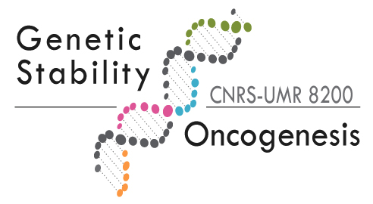 |  | 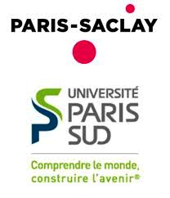

Post-doctoral position in the field of cell cycle regulation and genetic stability

Our team is currently studying the signaling pathways that control a timely entry into mitosis in mammals, as well as their deregulations and consequences under pathological conditions. Complete replication of the genome and initiation of mitosis must be tightly coordinated in space and time to preserve the integrity of the genetic content transmitted to the cell offspring. This post-doctoral project aims to elucidate the molecular mechanisms by which S-promoting factors CyclinA2-Cdk1&2 control the timing of commitment to mitosis.
For further details: Gheghiani L., Loew D., Lombard B., Mansfeld J. and Gavet O. (2017). Plk1 activation in late G2 sets up commitment to mitosis, Cell reports, Jun 6;19(10):2060-2073

Our team is part of the UMR8200 CNRS research unit "Genetic stability and Oncogenesis" located at the Gustave Roussy Institute, the leading cancer research center in Europe (~20 min from downtown Paris). The Institute has different on site facilities for live cell imaging (confocal, spinning disk), intravital imaging in animals, flow cytometry, bioinformatics and genomics. The candidate will benefit from a stimulating scientific environment with several research groups working on DNA replication/repair mechanisms and signaling pathways activated in response to genotoxic stress (DDR).

Requirements
The candidate must have a PhD in science and a strong background in molecular biology, cell biology and image analysis. Expertise in genetic approaches such as CRISPR/Cas9 will be appreciated. The candidate must have a solid track record with at least one first author publication in a peer reviewed journal from his/her PhD work. He/She must be autonomous and very rigorous in carrying out experiments, and have excellent organizational skills.

The candidate will work under the scientific supervision of O. GAVET and must:
- carry out regular bibliographic monitoring related to the project
- participate in the design of the project
- use all the techniques already established in the laboratory to study cell proliferation and genetic stability
-design and carry out the experiments independently (notably, functional perturbation assays and monitoring of cell proliferation by video microscopy approaches; quantitative image analysis)
- Independently analyze the results obtained
- present the data (laboratory meetings, seminars)
- write publications

What we offer
The initial contract for 12 months is funded by the ANR (Agence Nationale de la Recherche), expecting that the candidate will further apply for its own funding with the support of the laboratory.
Salary from 2695 to 3841 euros gross monthly salary according to post-doctoral experience.

How to apply
Interested candidates should send their CV and a cover letter summarizing their scientific interests, as well as the full contact details of 2 scientists who may provide recommendations to Olivier.gavet@gustaveroussy.fr

