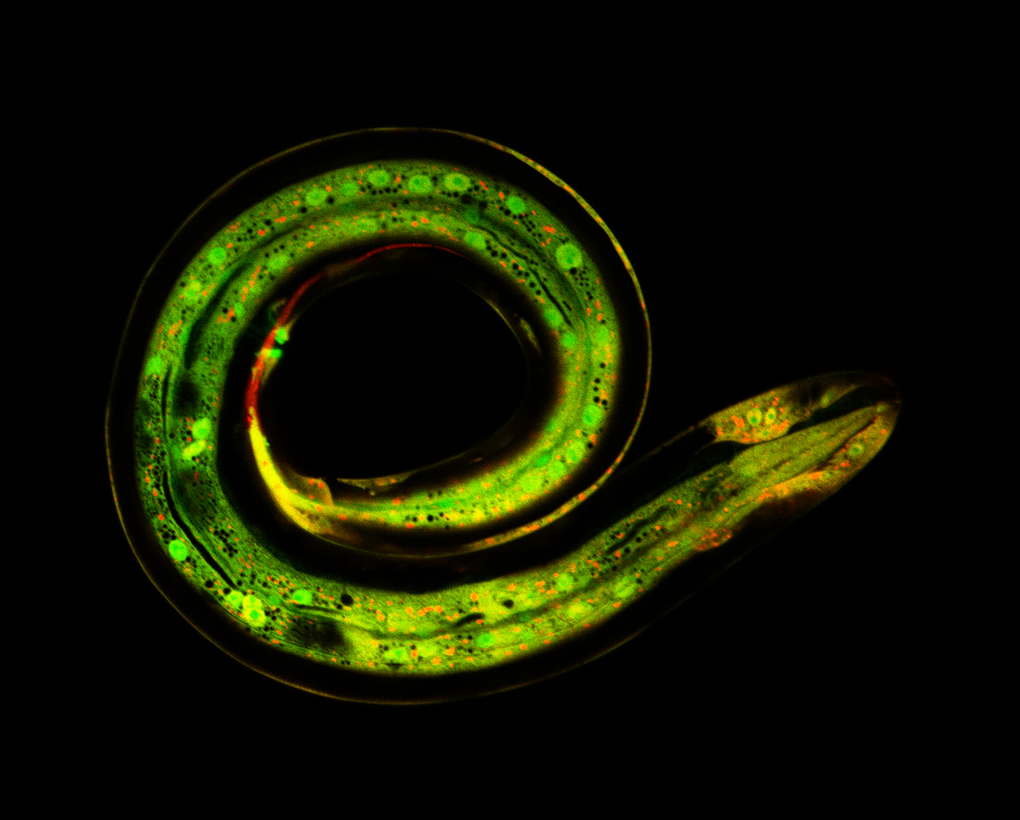
Post-doc position at CIML, Marseille, France on the cell biology of wound responses
A postdoctoral position is currently available in the Pujol_Ewbank Laboratory, part of the Labex INFORM and Turing Centre for Living Systems (CENTURI), to study the cellular and molecular response to damage, or how wound healing and immune responses are coordinated in a single cell.

Description: We are looking for a highly motivated, enthusiastic and interactive postdoctoral candidate to join our multidisciplinary research team. The ideal candidate should have a strong background in Cell biology and Genetics. The research in our lab is focused on studying the molecular and cellular mechanisms underlying the response to damage in the C. elegans epidermis. This involves deciphering the chemical and mechanical triggers and understanding the links between signalling and cytoskeletal remodelling. In our work, we use in vivo imaging to capture cell biological changes provoked by injury, combined with genetic, genomic and biophysical approaches. Experience in invertebrate model genetics is desirable but not necessary. The successful postdoc candidate will receive training in genetics, molecular and cell biology approaches for C. elegans research.

For details of the research project, please refer to our recent MS: https://www.biorxiv.org/content/10.1101/512632v1.

The position is available for 2 years with the possibility to apply for extension. Interested candidates should send a CV, a description of research experience and contact information for two references to Nathalie Pujol pujol@ciml.univ-mrs.fr

Selected publications:
Taffoni C. et al. 2019. Microtubule plus-end dynamics link wound repair to the innate immune response. BioRXiv 512632.
Dodd W. et al. 2018. A Damage Sensor Associated with the Cuticle Coordinates Three Core Environmental Stress Responses in C. elegans. Genetics 208, 1467-1482.
Zugasti O. et al. 2016. A quantitative genome-wide RNAi screen in C. elegans for antifungal innate immunity genes. BMC Biol 14, 35.
Kim K.W. et al. 2016. Coordinated inhibition of C/EBP by Tribbles in multiple tissues is essential for C. elegans development. BMC Biol 14, 104.
Ewbank J.J. and Pujol N. 2016. Local and long-range activation of innate immunity by infection and damage in C. elegans. Curr Opin Immunol 38, 1-7.
Zugasti O. et al 2014. Activation of a G protein-coupled receptor by its endogenous ligand triggers the innate immune response of C. elegans. Nat Immunol 15, 833-838.
Rouger V. et al. 2014. Independent Synchronized Control and Visualization of Interactions between Living Cells and Organisms. Biophysical journal 106, 2096-2104.
Dierking K. et al. 2011. Unusual regulation of a STAT protein by an SLC6 family transporter in C. elegans epidermal innate immunity. Cell Host Microbe 9, 425-435.

