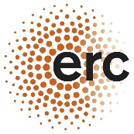
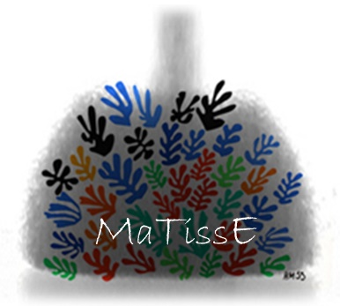
Two years postdoctoral fellowship in magnetic bioengineering

A 2-yrs (+1-y renewable) post-doctoral position supported by the European Research Council (ERC MaTissE) is opened in the Biother team of MSC laboratory, in Paris. This postdoctoral fellowship is at the interface between biophysics, bioengineering and cell biology.

Nanotechnology has quickly swept across the medical field by proposing sometimes unprecedented solutions at the furthest limits of current treatments, thereby becoming central to diagnosis and therapy, notably for the regeneration of tissue. A current challenge for regenerative medicine is to create a cohesive and organized cellular assembly without using an external supporting matrix. This is a particularly substantial challenge when it involves synthesizing thick and/or large-sized tissue, or when these tissues must be stimulated like their in vivo counterparts in order to improve their functionality. Another transversal challenge for the tissue engineering field is to develop and mechanically probe model tissues to advance the knowledge of tissue biophysics and mechanics. We have developed a series of magnetic tools to tackle these challenges.
In the present project, we will first explore the role of the extracellular matrix in tissue mechanics thanks to an unprecedented in situ magnetic tissue rheometer. We will develop further a magnetic tissue stretcher to generate engineered tissues presenting cellular anisotropic alignment and we will map the intra-tissular local forces during stretching. Moreover we will identify the best magnetic nanomaterials to provide a high but safe intracellular magnetic load by preventing nanobiodegradation.

Qualified candidates should have a PhD in biophysics and bioengineering or biomechanics with a solid background in cell culture and microscopy. Any knowledge in nanomedical technologies or nanomedicine is also welcome. Excellent level of written english is required. For application, please contact: Claire Wilhelm (claire.wilhelm@univ-paris-diderot.fr) and Myriam Reffay (myriam.reffay@univ-paris-diderot.fr).

http://biother.net/
e.g. A 3D magnetic tissue stretcher for remote mechanical control of embryonic stem cell differentiation. Nature Communications, 8(1), 400 (2017); Successful chondrogenesis within scaffolds, using magnetic stem cell confinement and bioreactor maturation. Acta Biomaterialia, 37, 101-110 (2016); Magnetic flattening of stem-cell spheroids indicates a size-dependent elastocapillary transition. Phys Rev Lett, 114, 098105 (2015); Magnetic engineering of stable rod-shaped stem cell aggregates: circumventing the pitfall of self-bending. Integrative Biology, 7, 170-177 (2015) Magnetically shaped cell aggregates: from granular to contractile materials. Soft Matter, 10, 5045-54 (2014); High resolution multiplex MRI: gadolinium and iron oxides nanoparticles for in depth imaging of multi-cellular engineered tissue constructs. ACS nano, 7, 7500–7512 (2013); Design of biomimetic vascular grafts with magnetic endothelial patterning. Cell Transplantation, 22, 2105-18 (2013); Magnetic forces promote stem cell differentiation, aggregates fusion and tissue building. Advanced Materials. 25, 2611-2616 (2013); Methods for aggregation and differentiation of magnetized stem cells Patent FR2979634-A1; WO/2013/030393 (2013)
In collaboration with Atef Asnacios.
e.g. Magneto-Thermal Metrics Can Mirror the Long-Term Intracellular Fate of Magneto-Plasmonic Nanohybrids and Reveal the Remarkable Shielding Effect of Gold. Adv Funct Mat, 27, 1605997 (2017); Massive Intracellular Biodegradation of Iron Oxide Nanoparticles Evidenced Magnetically at Single Endosome and Tissue Levels. ACS Nano, 10, 7627- 38 (2016)

