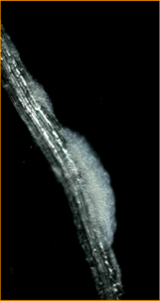
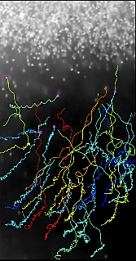
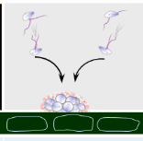

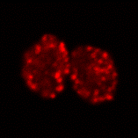

Post-doctoral position in Molecular and Cellular Microbiology
“Collective motion of Phytophthora zoospores”
Institut Sophia Agrobiotech (ISA), Team IPO (Eric Galiana)
Institut de Physique de Nice (INΦNI), Team MIMIC (Xavier Noblin)

Summary : A 1-year postdoctoral position is available at the Institut Sophia Agrobiotech (ISA, INRA -Université Côte d’Azur-CNRS) at Sophia Antipolis, France. The lab is hiring a postdoc to work on a collaborative project involving biologists and physicists, funded by UCA-JEDI (Plant bioprotection and Biostimulation program). The study is focused on understanding how Phytophthora zoospores control their motion in relation to their ability of undergoing aggregation in vitro and biofilm formation on host surface. The goal is to delineate signaling and cellular responses, as well as metrics of zoospores as active matter during collective motion.
The work will be mainly performed at the Institut Sophia Agrobiotech (https://www6.paca.inra.fr/institut-sophia-agrobiotech) in strong interaction with the Institut de Physique de Nice (Xavier Noblin, www.inphyni.cnrs.fr/) in which a post-doc will develop at the same time biophysics of zoospores. For investigation on signaling aspects, the work will also involves a team in the Laboratoire de PhysioMédecine Moléculaire, Laurent Counillon, http://unice.fr/lp2m/fr). A modelling investigation involves a group in the Mathematics institute (Laboratoire J-A Dieudonné, Fernando Peruani).
Job Requirements : Ph.D. in Molecular and cellular Microbiology or related field with an emphasis in Plant Pathology. Candidates should have experience with transcriptomics, as well as skills in bioinformatics and R language. Backgrounds in quantitative cell imaging is also highly desirable. An interest to (i) interdisciplinary development and (ii) articulation between basic and applied research on developing tools for managing plant diseases will be greatly appreciated.
Pay scale is commensurate with experience. Please, email your application to Eric Galiana, at eric.galiana@inra.fr, as a PDF file, which includes a cover letter summarizing your experience, a C.V. including your publications, and names and contact information of references.
Closing Date: 31.03.2018
Relevant publications:
- Ochiai N, Dragiila MI, Parke JL: Pattern swimming of Phytophthora citricola zoospores: an example of microbial bioconvection. Fungal Biol 2011, 115(3):228-235.
- Savory AIM, Grenville-Briggs LJ, Wawra S, van West P, Davidson FA: Auto-aggregation in zoospores of Phytophthora infestans: the cooperative roles of bioconvection and chemotaxis. J R Soc Interface 2014, 11(94).
- Galiana E, Fourre S, Engler G: Phytophthora parasitica biofilm formation: installation and organization of microcolonies on the surface of a host plant. Environ Microbiol 2008, 10(8):2164-2171.
- Larousse M, Galiana E: Microbial Partnerships of Pathogenic Oomycetes. PLoS Pathog 2017, 13(1):e1006028.
- Larousse M, Rancurel C, Syska C, Palero F, Etienne C, Industri B, Nesme X, Bardin M, Galiana E: Tomato root microbiota and Phytophthora parasitica-associated disease. Microbiome 2017, 5(1):56.

